
NAGONGERA CAMPUS
FACULTY OF SCIENCE AND EDUCATION
DEPARTMENT OF COMPUTER STUDIES

COURSE UNIT: DATABASE MANAGEMENT SYSTEMS
COURSE CODE: BIT 3101
STUDENT: KITARA OKELLO EMMANUEL
REG NO: BU/UP/2023/1495
LECTURER: DR. ANGOLE RICHARD

- Inventory Control System
Entities/Objects and Schema
The main entities are Product, Category, Employee, Supplier, Purchase Order, and Tracking (for sales/wastage).
Entity (Table) | Attributes (Columns)
CATEGORY | Category_ID (PK), Name
PRODUCT | Product_ID (PK), Name, Reorder_Level, Category_ID (FK)
SUPPLIER | Supplier_ID (PK), Name
EMPLOYEE | Employee_ID (PK), Name
PURCHASE_ORDER | PO_ID (PK), Order_Date, Product_ID (FK), Supplier_ID (FK), Employee_ID (FK), Quantity
TRACKING | Tracking_ID (PK), Product_ID (FK), Date, Type (Received/Sold/Wastage), Quantity

ERD (ENTITY RELATIONSHIP DIAGRAM) LOGICAL
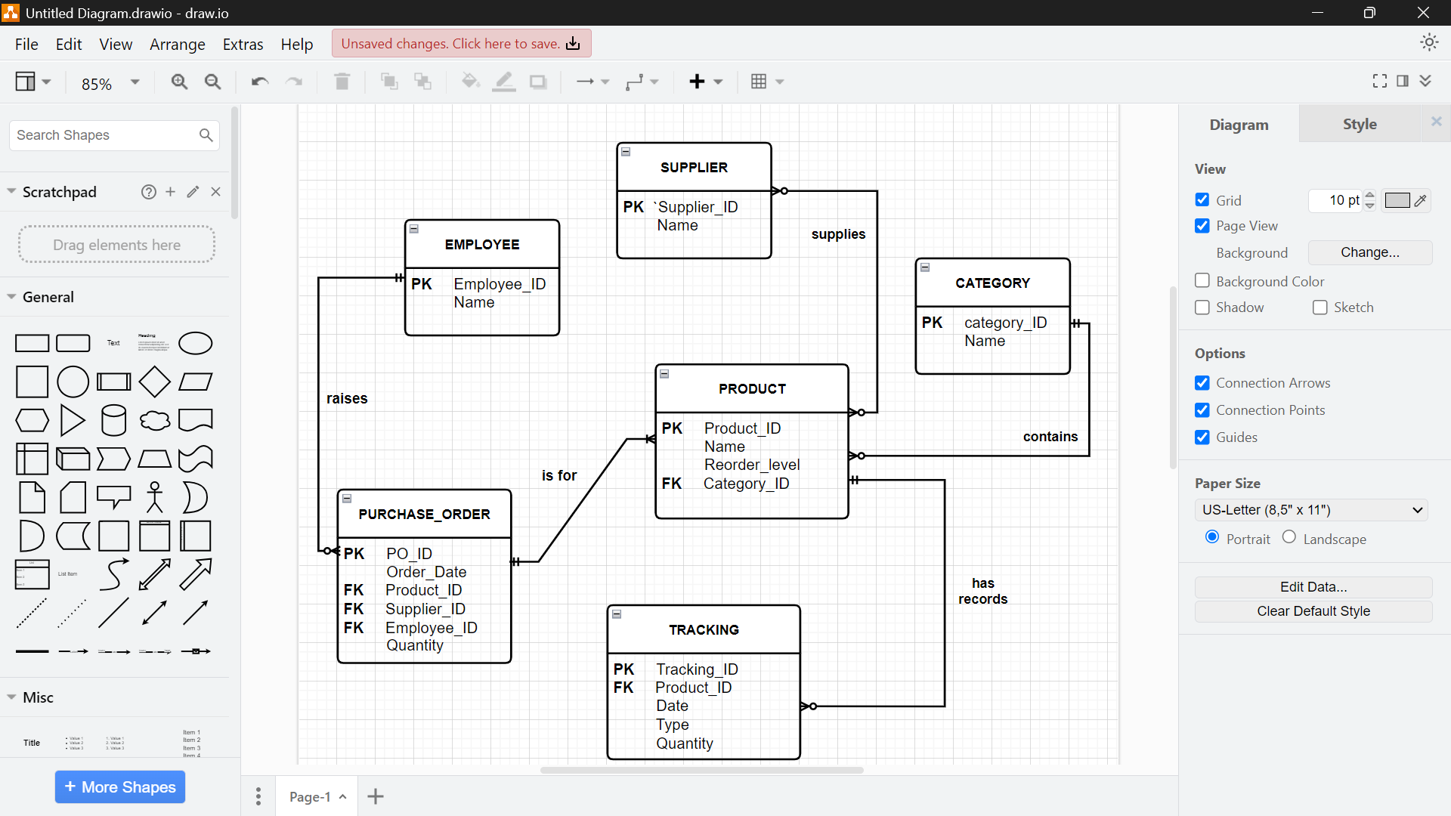
- CATEGORY 1:M PRODUCT: A Category can have many Products, but a Product belongs to only one Category.
- PRODUCT M:M SUPPLIER: A Product can be reordered from many Suppliers, and a Supplier supplies many Products. (Handled via PURCHASE_ORDER).
- EMPLOYEE 1:M PURCHASE_ORDER: An Employee raises many Purchase Orders.
- PRODUCT 1:M PURCHASE_ORDER: A Purchase Order is for a specific Product.
- PRODUCT 1:M TRACKING: A Product has many Tracking records (supplies, sales, wastage).
- PURCHASE_ORDER 1:1 TRACKING (Supply Type): A Purchase Order results in a supply entry in the Tracking records.

- Client Requests for Printing System
Entities/Objects and Schema
The main entities are Book_Publisher (Client), Print_Job (Order), Material, Purchase_Order, Print_Manager, and Employee.
Entity (Table) | Attributes (Columns)
BOOK_PUBLISHER | Publisher_ID (PK), Name
PRINT_MANAGER | PM_ID (PK), Name
EMPLOYEE | Employee_ID (PK), Name
PRINT_JOB | Job_ID (PK), Publisher_ID (FK), PM_ID (FK), Description
JOB_MATERIAL | Job_ID (FK, PK), Material_ID (FK, PK), Quantity
MATERIAL | Material_ID (PK), Name (Paper/Ink/etc.)
PURCHASE_ORDER | PO_ID (PK), Job_ID (FK), Material_ID (FK), PO_Date
JOB_EMPLOYEE | Job_ID (FK, PK), Employee_ID (FK, PK)

ERD (ENTITY RELATIONSHIP DIAGRAM) LOGICAL
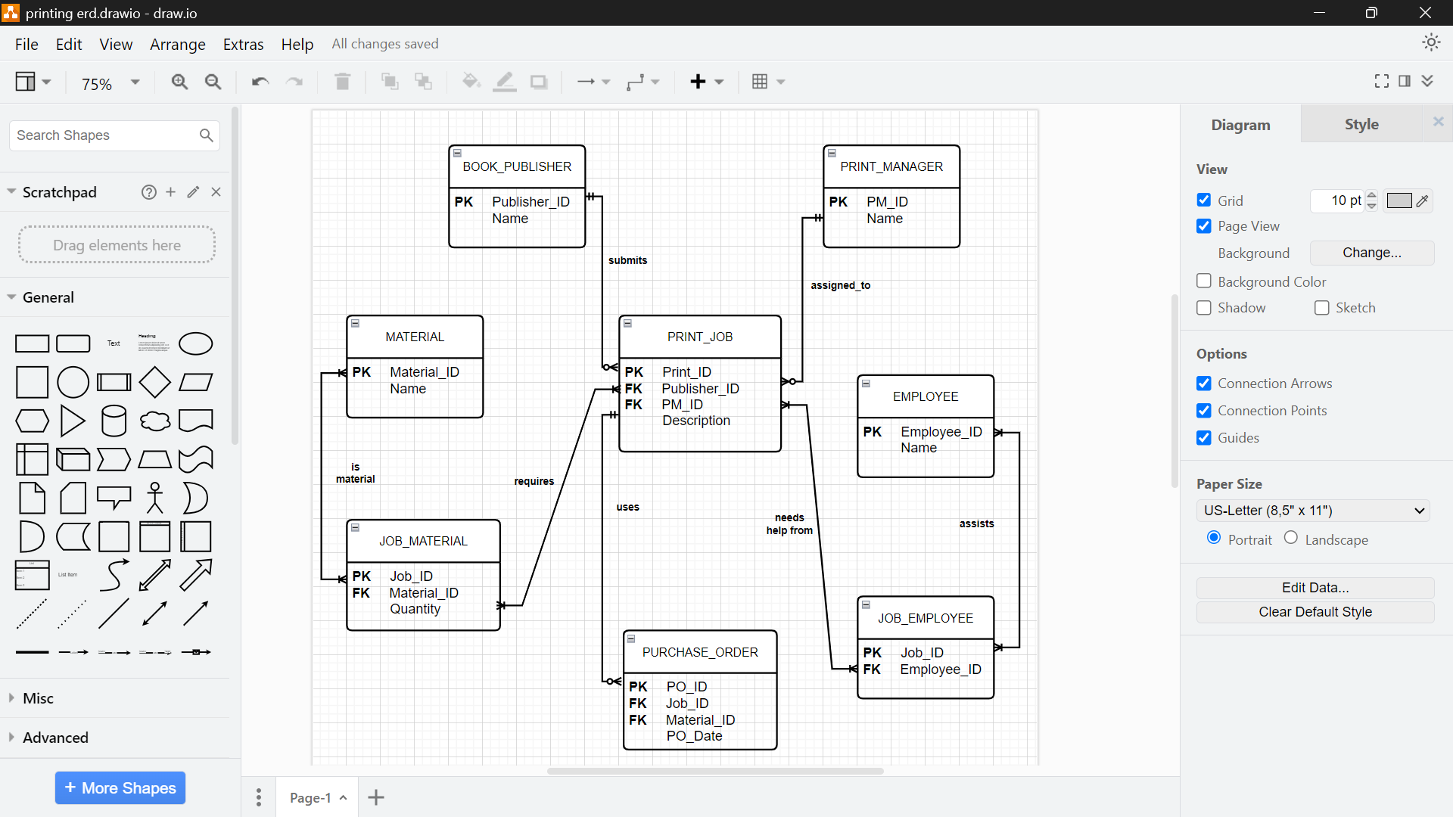
- BOOK_PUBLISHER 1:M PRINT_JOB: A Publisher submits one or more Print Jobs.
- PRINT_MANAGER 1:M PRINT_JOB: A Print Manager is assigned to one or more Print Jobs.
- PRINT_JOB M:M MATERIAL (via JOB_MATERIAL): A Print Job requires the use of Materials.
- PRINT_JOB 1:M PURCHASE_ORDER: Materials are assigned to a job through one or more Purchase Orders.
- PRINT_JOB M:M EMPLOYEE (via JOB_EMPLOYEE): Employees are allocated to help with larger Print Jobs.

